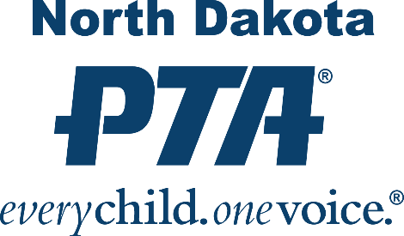

**2024-2025 PTA and PTSA OFFICERS and CHAIR FORM**

This Officer’s form is a required document for each NDPTA Unit to complete and return to the NDPTA State Office to remain a Unit In Good Standing. North Dakota law requires each registered organization to report a list of officers. Each unit must provide the necessary information by the requested date to ensure all communications from both the state and National PTA are delivered on time.

Please return form by mail, email or MemberHub update by **May 15, 2024**. In the instance, no elections were held or no new officers were elected, please notify the State Office.

**NDPTA**

**PO Box 943**

**Fargo, ND 58107**

**northdakotapta@gmail.com**

**Full Name of School PTA or PTSA**: __________________________________________

**PTA PRESIDENT Name: ________________________________________________________**

**E-mail: ________________________________________________________** **Phone: ________________________________________________________**

**VICE PRESIDENT Name: _______________________________________________________**

**E-mail: _______________________________________________________**  
   
 **Phone: _______________________________________________________**

**SECRETARY** **Name: _______________________________________________________**

**E-mail: _______________________________________________________  
   
 Phone: _______________________________________________________**

**TREASURER Name: _______________________________________________________**

**E-mail: _______________________________________________________**

**Phone: _______________________________________________________**

**MEMBERSHIP Name: _______________________________________________________**

**E-mail: _______________________________________________________  
   
 Phone: _______________________________________________________**

**REFLECTIONS Name: _______________________________________________________**

**E-mail: _______________________________________________________  
   
 Phone: _______________________________________________________**

Officers may be entered into your unit’s MemberHub site instead of mailing the form. If you did not have elections in the spring, please email us to let us know!